PR #8 Next Two Finishers for Race to the Sky 2023

TO: All Media
FROM: Pam Beckstrom, 881-2909, info@racetothesky.org
RE: Race to the Sky Projected Finish of 300
DATE: February 13, 10 p.m.

Jessie Royer won the 2023 Race to the Sky 300 mile at 7:40 this evening. Royer is from Seeley Lake, Montana. She has been mushing for 31 years and operates the J Team Kennel. She has now won the Race to the Sky seven times. After first winning the 500 mile race when she was 17 years old, she started training to run Iditarod. She has finished may Iditarod (over 1,100 miles) races and has several third place finishes recently. She is headed back to Iditarod next month.

Erik Oline was next to cross the finish line at 8:48 p.m. with 12 dogs, finishing in second place. Oline is a fishing guide and college student from Missoula, Montana. He is running dogs from the J Team Kennel (Jessie Royer’s) that he has been running all season doing tours. This is his second year running tours for Royer and running Race to the Sky. This year the 300 mile, last year he finished the 100 mile race.

Charmayne Morrison finished the Race to the Sky 300 in third place at 10:15 p.m. with 8 dogs.

She has been mushing for 8 years, starting with the Junior Race to the Sky and finished the 2019 and 2020 Race to the Sky 100 in third place. In 2020, she was the Rocky Mountain Triple Crown 8 dog champion. She is planning on running Iditarod.

Clayton Perry is scheduled to leave at 11:15 tonight to head to the finish line. He is expected to finish between 4 and 5 a.m. Tuesday morning at Hi-Country Snack Foods.

Awards ceremony will be at 1:00 Tuesday at Hi-Country Snack Foods Trading Post for the 300 mile teams. The public is always invited to attend.

Recap:

1st place Jessie Royer Seeley Lake, Montana
2nd place Erik Oline Missoula, Montana
3rd place Charmayne Morrison Bozeman, Montana

Clayton Perry should finish early morning.

Photos below
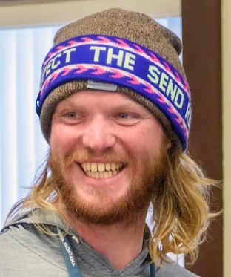 Erik Oline, Missoula, Montana

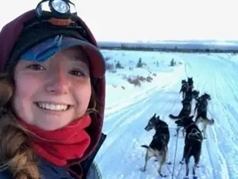 Charmayne Morrison, Bozeman, Montana

